http://www.arguingindia.blogspot.com/

Farmers' widows & children in Wardha: RV Bhavani
R V Bhavani, Director, B V Rao Centre for Sustainable Food Security, M S Swaminathan Research Foundation has sent us the following article
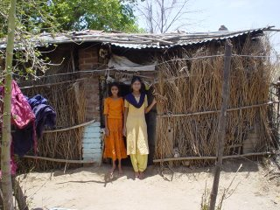
Linisha and Bharti Bhatero outside their ramshackle hut in Wadgaon village, Seloo block, Wardha
Over 60 percent of India's population is rural and dependent on agriculture and allied activities for their livelihood. The landholding situation is highly skewed with the majority being small and marginal farmers with landholdings of 2 hectare and less. The share of agriculture in the Gross Domestic Product has however been falling over the years. So has investment in agriculture per se as well as investment on agriculture research and in rural infrastructure - a phenomenon that has characterised the neo-liberal reform period beginning in the nineties. Insurance for crop failure is virtually non-existent. The agriculture extension system has failed. The farmer is largely left to take a beating on the Input (Credit, Technology, Inputs) and Price and Market fronts. Increasing number of suicides by farmers in rainfed farming areas (mainly the states of Andhra Pradesh, Karnataka and Vidarbha region of Maharashtra) since the late nineties is a manifestation of a serious malaise afflicting the Indian economy today. In fact, these are danger signals for the policy makers to sit up and take note but that sadly is not happening.
Their husbands/fathers have taken their lives, leaving behind the mothers and children to cope with the harsh realities of everyday existence. The situation is bleak; what do they have to look forward to, is the question that keeps coming to mind when one meets and speaks with them. It is a question of surviving from day to day. Most of the widows now work as farm labour and the children also go to work during weekends and holidays. While the women/girls get Rs.25/- to Rs.30/-, for five hours of work, the boys get about Rs.50 (in both cases, less than a dollar). In some families, atleast one son has dropped out of school to help their mother with farm work. In some families, the older son had been in a crucial year at school when the father committed suicide and that put an abrupt end to studies. The land in most cases is joint property or in the in-laws’ name. One could feel the anger in 17 year old Linisha’s voice, from Wadgaon village in Wardha district, when she said that her uncle now cultivates the land they had and her mother goes out to work as farm labour. Linisha has given her class X exams and would like to study further. Her sister Bharti, 13 has gone to class VIII. Their home is a ramshackle hut with asbestos roofing and mud flooring in the front room.
The insensitivity with which the agrarian distress relief packages are being implemented and the general apathy especially at the lower levels of administration also comes to light. Usha Dhale of Rohankheda village shelled out Rs.4000/- for a cow under the relief package. The cow is not yielding any milk and is an additional liability. Her father has taken it to his village so that it is not a burden on her. Asha Kurwade from Khambit village in Ashti block with one acre of land and no well was thrust with an engine for which she had to shell out Rs.5000/-. She has since borrowed from a moneylender at a rate of 5% per month to meet expenses when her children fell ill. 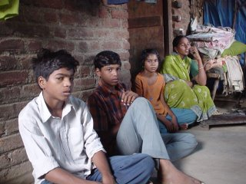
Asha Kurwade with her children, Khambit village, Ashti block, Wardha - what does the future hold for them?
The license for the fair price shop that Sushila’s husband Prakash Taksande used to run in Kharda village of Deoli block in Wardha district was withdrawn when he committed suicide. His wife, young Sushila who, hats off to her resilience, manages to have a smiling face all the time, was not considered for running the same, inspite of being class IX pass. She has not got any suicide relief either. The household of mother and two sons aged 12 and 7, runs on the rupees ten thousand she gets annually by leasing her four acre plot of land. In one village, the post office cuts Rs.20/- per child from the instalment deposited in the post office savings account as monetary support for education by a NGO.
Most families still have the debt outstanding, to the pressure of which their husbands succumbed, hanging over their heads. Some suffer from health problems, following the trauma of the husband’s death. What is however heartening in the scenario of gloom, are the aspirations of some of the children to study and the endeavor of the mothers to stand by them and strive to ensure that their desires are fulfilled. Nineteen year old Amol from Ashti village whose mother works as a helper at the anganwadi centre in the village will be completing an ITI course in wire work this year and hopes to take admission in class XI. Some of the families have children who are going to take their first steps in schooling and go to the balwadi or class I, and have a long way ahead.
The least the larger community could do is to ensure that these children do see some hope at the end of the tunnel and their aspirations are not thwarted even before they have taken shape. While it is a fact that by and large the scenario is not going to improve unless the ground realities of the agriculture that they do changes and necessary infrastructure and support services are in place, immediate support to the widows and their children is imperative. A small pilot initiative steered by the M S Swaminathan Research Foundation, a non-profit trust, is on in Wardha district of Vidarbha, where children of school going age from farmer suicide families are getting monetary support to ensure that they continue their education. 77 children from 37 families spread across the eight blocks of the district are covered at present. Children completing class X and XII now need help and counseling by way of courses they could join that would also give them some income earning skills instead of just leading to a run of the mill degree with no assurance of a job at the end of the day. The Rural College at Pipri, Wardha for instance offers a two-year diploma course in agriculture. Students undergoing the programme can if they wish to study further apply for admission to any degree programme other than engineering and medicine. Alternately, the diploma is also considered as valid qualification for certain jobs in the district administration. Children who had to drop out due to the sudden tragedy can also benefit by acquiring some vocational training skills that will help them to earn some additional income besides working just as farm labour. For instance, Nilesh, 19 of Paloti village is class X fail; so are brothers Narayan, 23 and Nitin, 22 of Sawli Wagh village. The Community Polytechnic at Pipri, Wardha offers six-month certificate courses in computer hardware repair, TV repair, two-wheeler repair, welding, electrical work etc. Undergoing such training can help them have an additional income earning skill in hand.
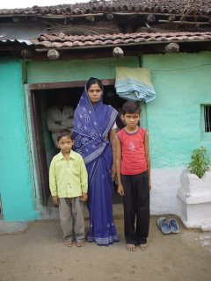Ranjana with sons Abhishek (Class I) and Suraj (Class VI), Chincholi village, Karanjha block, Wardha: A long way to go...
Livelihood rehabilitation for the widows is also a matter of concern. Many have qualification ranging from class VIII pass to Class XII pass. Many are quite young too, in their early twenties to mid thirties. Most as mentioned earlier now work as farm labour. Life has virtually stopped midway on the tracks for them. Training in some skill that they can put to use while in their respective villages and make some money can help them get confidence, but it is also a challenge. A village may have only one such affected woman. The villages are spread out across the district, some being a hundred kilometers from the district headquarter, making a plan to bring them together for long periods of training difficult. Some of the women are members of self help groups. But only in one case we heard of a Self Help Group (SHG) having started a goatery enterprise with bank loan. Moving from just saving and lending to enterprise development and management is crucial if the quality of life is to improve. Uppermost on the minds of the mothers however, is the worry on what the future holds for their children, on what will happen after they have completed schooling so that they get a better deal in life.
Wardha abounds in educational institutions some with international renown; there are also many research institutes in the vicinity like the Central Institute of Cotton Research and National Bureau of Soil Science and Landuse Planning at Nagpur, just 70 kilometres away; The College of Agriculture in Nagpur is a century old. There is no dearth of intellectual capital either. The banks in the district led by Bank of India and State Bank of India, have undertaken a financial inclusion initiative. Historically, Wardha happens to be the base from where Gandhiji steered India’s freedom struggle and had all the potential for developing as a ‘Gandhi Zilla’ where everyone has a means of secure livelihood and can lead a life of dignity. Sixty years on however, the challenge is to stave the ignominy of being labeled a farmers’ suicide district.

