Curriculum for Early Childhood Care and Education
A National Perspective

Mina Swaminathan*

Abstract

The National Focus Group (NFG), set up by NCERT for the National Curriculum Framework (NCF) Review in 2004, worked to lay the guidelines to provide quality ECCE services. The current paper throws light on these guidelines.

The first six to eight years of a child's life are the most crucial in terms of lifelong development, since the pace of development is extremely rapid in this period. Not only that, research shows that the early years are the most critical in terms of forming synaptic connection in the brain, as indicated in the Figure 1 below. For example, the development of cognitive skills, language and symbolic thought is at its most critical stage during the years 2-4.

Figure 1: Critical period of some aspects of brain development and function

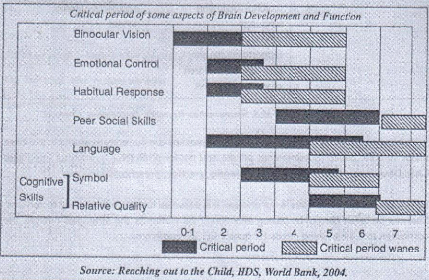

Research also shows that if the early years are not supported by a stimulating and enriching physical and psycho-social environment, the chances of the child's brain developing to its full potential are considerably, and sometimes irrevocably, reduced. Hence, the crucial importance of investing in the early years and ensuring an enabling environment ensure a sound foundation for life. Unfortunately, the reality in our country is that actual spending per child, on children below 6 years, is only about one-eighth of the spending per child in the 6-14 years group. It is possible to indicate what the needs of the children are at each sub-stage, as shown in the Table 1 below.

Table 1: Needs of children

Before birth / women | Birth to 2 years | 3-5 years
Anti-natal care  Safe child birth  Post natal care  Nutrition  Maternity entitlements  Support services | Protection from hazards  Nutrition  Health Care  Attachment to an Adult  Opportunity for sensory- motor,  Psycho-social and language development  Opportunity for play  Day care for children of working women | Opportunity to develop motor, social, cognitive and language skills  Preparation for  school by learning  pre- literacy and  pre-numeracy skills  Access to primary school.
Source: Project ACCESS, M.S. Swaminathan Research Foundation, Chennai.

With these needs in mind various services/programmes are currently available in the three major sectors: public (government), private and not-for-profit (NGO), such as Integrated Child Development Services (ICDS), Balwadis, creches, preschools etc.

Merely providing the services is not enough. It is essential to ensure the quality of services. This can be taken care of by paying attention to the elements, the strategies needed, the curriculum and the training needs for quality ECCE programme.

Elements of Quality ECCE

Coming to the age group 3-5 years, the key issue today is not just the need to expand services to reach every child, especially as this is now accepted as a Directive Principle of our Constitution. But even more importantly, it is necessary to improve quality in all sectors, using different instrumentalities for each sector. What are the basic elements of quality in ECCE?

Curriculum
- activity-based, child-centred, age-appropriate, aiming at all-round development
- adapted to context and flexible

Teachers
- motivated
- appropriately trained through experiential 'hands-on' training
- recognized with status of teacher
- rewarded with appropriate pay

Ratio and group size
- that helps adult child interaction.

Infrastructure-supportive of Child’s needs
- low-cost and culture specific

Supervision and monitoring
- that encourages improving quality

Strategies Needed

The strategies needed to achieve the goal of quality ECCE are summarized in the following figure:

Figure 2: Strategies to ensure quality
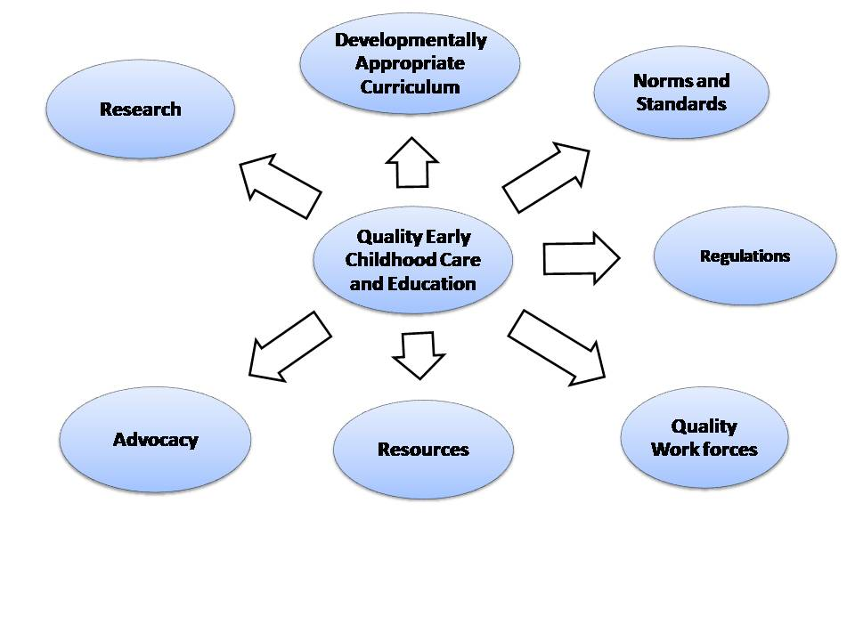

Source: National Focus Group on Early Childhood Education, NCERT, 2005

Curriculum for Early Childhood Care and Education

The curriculum is not a syllabus or a manual, but a broad framework to provide basic guidelines for curriculum and material development, classroom practice and teacher education. The document begins by first laying down the goals and then the objectives.

The goals are:

- Laying the foundation for a healthy, productive and satisfying life by enabling the child to develop his/her maximum potential
- Preparing the child for entry and success in primary school
- Providing support services to women and girls to enter/continue with education, training and being part of the work force.

The objectives are:

- Developmentally and age appropriate, activity-based curriculum related to the child's needs, interests and abilities.
- An integrated set of experiences to foster holistic growth and development in all domains, (health and well being, cognitive, physical, social, emotional and language), through an interlinked approach.
- Flexible enough to suit diverse social, cultural, economic and linguistic contexts as well as individual differences among children.
- Able to help the child to adjust to the routines of the primary school and to more formal teaching.

The experiences needed for development are:

Freedom from undue adult restraints through
- Exploration
- Experimentation
- Encouragement and challenge

Happiness of achievements for the individual through
  - Opportunity
  - Guidance
  - Support
  - Security and Safety

Adapting to be a member of a collective by
- Cooperating
- Listening
- Sharing
- Empathizing

Basic principles for development of curriculum are:

The following basic principles were laid down for development of curriculum

- Play as the basis for learning
- Art as the basis for education
- Recognition of the special features of children's thinking
- Blend of the textual (basic literacy and numeracy) and the cultural
- Mix of formal and informal interaction
- Familiarity and challenge in everyday rhythms
- Primacy of experience rather than expertise
- Developmentally appropriate practise and flexibility
- Use of local materials, arts and knowledge
- Integration of health, well being and healthy habits

Training Needs for ECCE

To transact any curriculum, teachers must be trained and fully aware of what they have to do and how they have to do it. This is even more true of a play-based curriculum; in the present situation, the majority of teachers in ECCE are untrained, inadequately trained or inappropriately trained. The diagram below summarizes the needs for training in ECCE.

Figure 3 : Training needs for ECCE

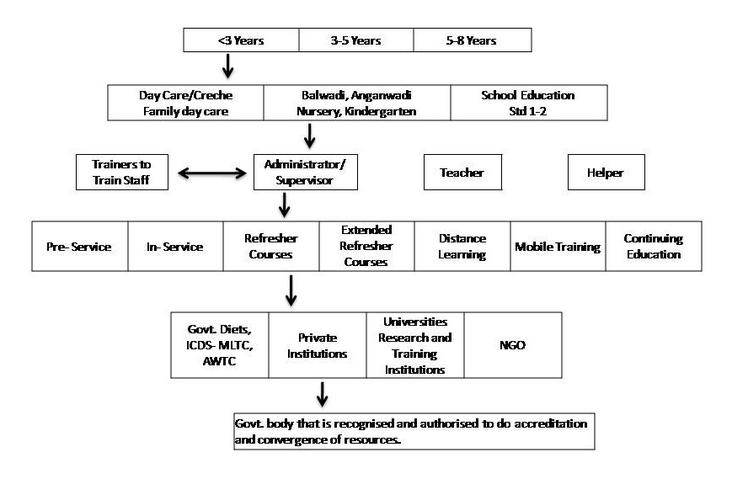

Source: National Focus Group on Early Childhood Education, NCERT, 2005

Finally, the NFG has also indicated the broad policy guidelines for a language in the ECCE classroom, based on the concept of multi-linguality. It is now well-accepted world-wide that early education should be in the child's first language (defined as beyond 'mother tongue' that is the language the child is familiar within the family, neighbourhood, kin group and community). However, where there are children in a classroom who come from different language backgrounds, (for example in large urban centres or remote tribal hamlets), the early years are the best time for children to understand (or use) more than one language, and to adjust gradually to the language that will be the medium of instruction later. There is a need of a sensitive and trained teacher to handle this kind of a multi-lingual classroom, through play. Further, since children can learn new languages with ease, a second language can be introduced as early as possible. The first language will continue to be the medium of instruction, but the classroom can be bilingual or mult-ilingual. As far as English is concerned, the demand for the language is now so widespread and powerful among all parents that it is no longer an academic issue, but a political compulsion, which the school system has to address as best as it can. English can be introduced within the multi-lingual classroom when the institution has the capability in terms of teacher proficiency in English or a second language, as well as teacher skills and training. Training is thus a key issue here, pointing once more to the importance of teacher education for transacting curriculum.

The NCF shows the path of providing quality ECCE services to young children. Now it is upto us to formulate the curriculum appropriately and train the workers in the field of ECCE so as to meet the developmental needs of the young children.

Section 2 Urban Poverty, Child Care and Crèches

6 | Children of the Urban Poor - Social Action
7 | Mobile Creches – the unfinished story

*Chairperson, National Focus Group on Early Childhood Education, NCERT, set up to prepare the National Curriculum Framework, 2005

